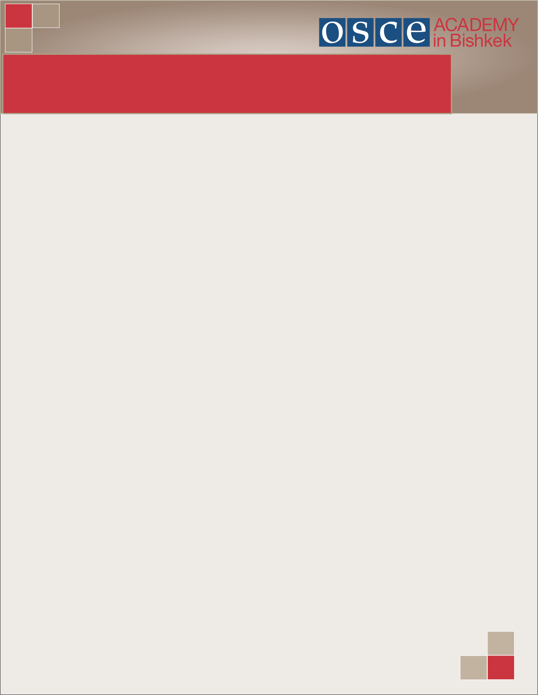The OSCE Academy in Bishkek is a public foundation, created in 2002 between the Kyrgyz Government and the Organization for Security and Cooperation in Europe (OSCE). The OSCE Academy promotes principles and values of the OSCE through post-graduate education, professional trainings and intellectual exchange. Its highly demanding MA Programmes in the fields of “Economic Governance and Development” and “Politics and Security (Central Asia)” annually enroll up to 60 young professionals from Kyrgyzstan, Kazakhstan, Uzbekistan, Turkmenistan, Tajikistan, Afghanistan and Mongolia on a competitive basis.

**Practical Information for Visitors of the OSCE Academy**

**LOCATION OF THE OSCE ACADEMY IN BISHKEK**

The OSCE Academy is located in the South–Western part of Bishkek, neighboring several universities (Kyrgyz State Technical University, Bishkek Humanities University, and Kyrgyz-Turkish Manas University). In its immediate vicinity of several restaurants and cafés, sport facilities and a variety of shops. The Academy is easy to reach via public transport with trolleybuses, buses and Marshrutki passing close by Kyrgyz State Technical University or Ata-Turk park.

**Address:**

1A Botanichesky pereulok

Bishkek, 720044

Kyrgyz Republic

Tel.: +996 (312) 54-32-00, 54-12-00

Fax: +996 (312) 54-23-13

[www.osce-academy.net](http://www.osce-academy.net)

[info@osce-academy.net](mailto:info@osce-academy.net)

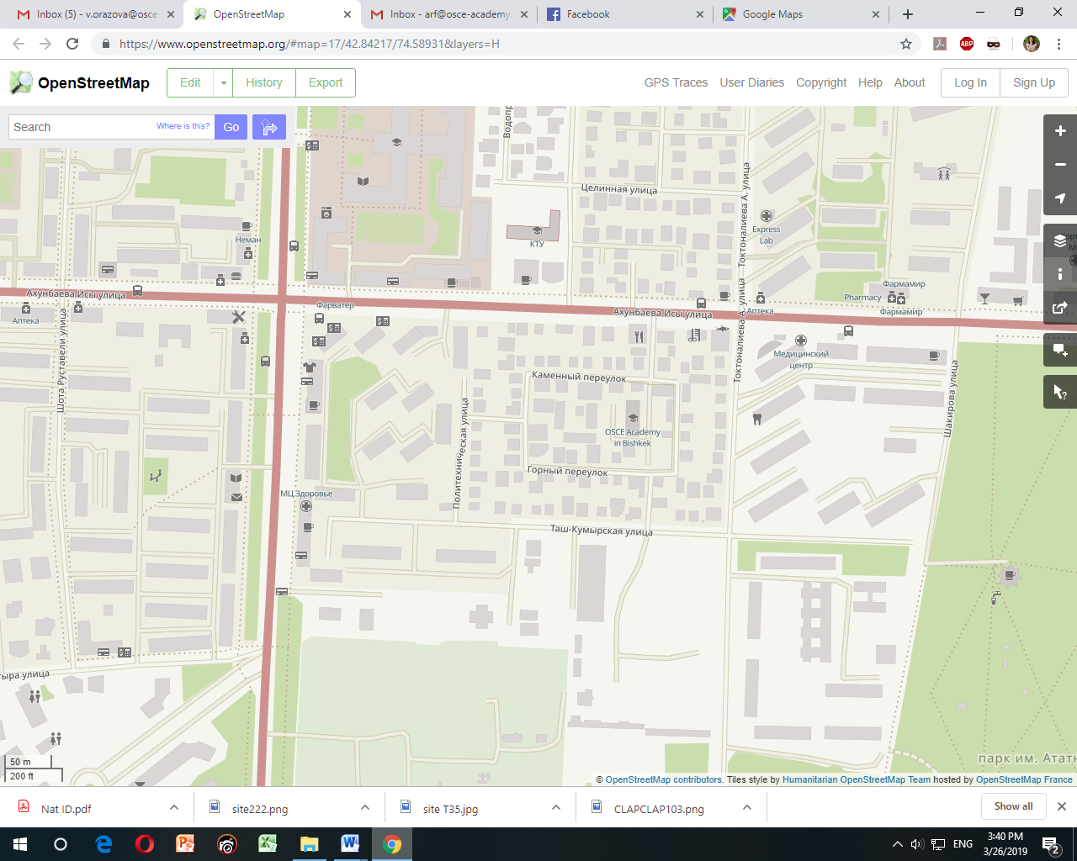Botanichesky pereulok is a small street, crossing Akhunbaeva Str. This crossroad is located between the intersections Ch. Aitmatov Ave./Akhunbaeva Str. and Toktonalieva Str./Akhunbaeva Str. one (see map).

Map from: <https://www.openstreetmap.org/#map=18/42.84295/74.58999&layers=H>

The reference point for the turn to Botanicheksy pereulok is Aman Bank (Akhunbaeva st 114) (see picture below).



**ACCOMMODATION**

Currently Bishkek can offer a number of options for accommodation: from hostels and guest-houses, private apartments to luxury hotels. Below are provided several options for guest houses, hostels and real state agencies:

|  |  |  |
| --- | --- | --- |
| NAME | ADDRESS | WEBSITE |
| Hostel 312 | Pereulok Chernishevskogo 30,  [Phone](https://www.google.com/search?hotel_dates=2018-07-15,2018-07-16&rlz=1C1CHZL_enKG781KG781&site=async/lcl_akp&q=greenhostel+bishkek+phone&sa=X&ved=2ahUKEwiuhs2H0JvcAhWGh6YKHcfXAfQQ6BMwBXoECAEQGg): [+996 706 468 687](https://www.google.com/search?q=Hostel+312+Bishkek&rlz=1C1CHZL_enKG781KG781&oq=Hostel+312+Bishkek&aqs=chrome..69i57j69i60j0.1727j0j7&sourceid=chrome&ie=UTF-8) | http://hostel312.kg/ |
| Green hostel | Ulitsa Skryabina,  [Phone](https://www.google.com/search?hotel_dates=2018-07-15,2018-07-16&rlz=1C1CHZL_enKG781KG781&site=async/lcl_akp&q=greenhostel+bishkek+phone&sa=X&ved=2ahUKEwiuhs2H0JvcAhWGh6YKHcfXAfQQ6BMwBXoECAEQGg): [+996 555 707 074](https://www.google.com/search?rlz=1C1CHZL_enKG781KG781&ei=k1tIW4CvHIyssAGE6q_QDQ&hotel_occupancy=&q=cheap%20hostels%20in%20Bishkek&oq=cheap+hostels+in+Bishkek&gs_l=psy-ab.3..0i22i30k1.26722.32661.0.34014.24.20.0.4.4.0.134.2170.0j19.19.0....0...1c.1.64.psy-ab..1.23.2197...0j0i67k1.0.vDOMMsz8-ZQ&hotel_dates=2018-07-15,2018-07-16&npsic=0&rflfq=1&rlha=1&rlla=0&rlhsc=Ch4IqaD475r43ZgLCPnalZy49ei4RAi99ufb3ZCy0gYwAQ&rllag=42871708,74592334,2628&tbm=lcl&rldimm=15006024013647682263&ved=0ahUKEwixzaWAz5vcAhXEWywKHQiNBNwQvS4IfzAA&rldoc=1&tbs=lf_hd:-1,lf_ho:2,lrf:!1m4!1u13!2m2!13m1!1b1!2m1!1e13!2m7!1e17!4m2!17m1!1e3!4m2!17m1!1e8!2m1!1e2!2m21!1e7!4m4!7m3!1m1!1u3000!3sKGS!4m4!7m3!1m1!1u4000!3sKGS!4m4!7m3!1m1!1u5000!3sKGS!4m4!7m3!1m1!1u6000!3sKGS!3sIAE,lf:1,lf_ui:6) | [http://greenhostel.kg](http://greenhostel.kg/" \t "_blank) |
| Silk Way Hostel | 119 Erkindik Ave,  [Phone](https://www.google.com/search?hotel_dates=2018-07-15,2018-07-16&rlz=1C1CHZL_enKG781KG781&site=async/lcl_akp&q=silk+way+hostel+phone&sa=X&ved=2ahUKEwjD1ZSR15vcAhUJCywKHXJMAkEQ6BMwBXoECAEQGg): [+996 704 506 094](https://www.google.com/search?rlz=1C1CHZL_enKG781KG781&ei=k1tIW4CvHIyssAGE6q_QDQ&hotel_occupancy=&q=cheap%20hostels%20in%20Bishkek&oq=cheap+hostels+in+Bishkek&gs_l=psy-ab.3..0i22i30k1.26722.32661.0.34014.24.20.0.4.4.0.134.2170.0j19.19.0....0...1c.1.64.psy-ab..1.23.2197...0j0i67k1.0.vDOMMsz8-ZQ&hotel_dates=2018-07-15,2018-07-16&npsic=0&rflfq=1&rlha=1&rlla=0&rlhsc=Ch4IqaD475r43ZgLCPnalZy49ei4RAi99ufb3ZCy0gYwAQ&rllag=42871708,74592334,2628&tbm=lcl&rldimm=15006024013647682263&ved=0ahUKEwixzaWAz5vcAhXEWywKHQiNBNwQvS4IfzAA&rldoc=1&tbs=lf_hd:-1,lf_ho:2,lrf:!1m4!1u13!2m2!13m1!1b1!2m1!1e13!2m7!1e17!4m2!17m1!1e3!4m2!17m1!1e8!2m1!1e2!2m21!1e7!4m4!7m3!1m1!1u3000!3sKGS!4m4!7m3!1m1!1u4000!3sKGS!4m4!7m3!1m1!1u5000!3sKGS!4m4!7m3!1m1!1u6000!3sKGS!3sIAE,lf:1,lf_ui:6) | https://www.ihr24.com/ho2920795/silk-way-hostel/en/ |
| Sky International Hostel | Kurenkeev Street 101  [Phone](https://www.google.com/search?hotel_dates=2018-07-15,2018-07-16&rlz=1C1CHZL_enKG781KG781&site=async/lcl_akp&q=sky+international+hostel+phone&sa=X&ved=2ahUKEwjK1fn23pvcAhWGFywKHd5DDSIQ6BMwBXoECAEQGg): [+996 505 588 555](https://www.google.com/search?rlz=1C1CHZL_enKG781KG781&ei=HFhIW7iTL4uQmgXqw62QCg&q=%D0%B4%D0%B5%D1%88%D0%B5%D0%B2%D1%8B%D0%B5%20%D1%85%D0%BE%D1%81%D1%82%D0%B5%D0%BB%D1%8B%20%D0%B2%20%D0%B1%D0%B8%D1%88%D0%BA%D0%B5%D0%BA%D0%B5&oq=%D0%BD%D0%B5%D0%B4%D0%BE%D1%80%D0%BE%D0%B3%D0%B8%D0%B5+%D0%BE%D1%82%D0%B5%D0%BB%D0%B8+%D0%B2+%D0%B1%D0%B8%D1%88%D0%BA%D0%B5%D0%BA%D0%B5&gs_l=psy-ab.1.3.0i71k1l8.0.0.0.10899.0.0.0.0.0.0.0.0..0.0....0...1c..64.psy-ab..0.0.0....0.a0HH_454ow0&hotel_dates=2018-07-15,2018-07-16&npsic=0&rflfq=1&rlha=1&rlla=0&rlhsc=Ch4IqaD475r43ZgLCPnalZy49ei4RAi99ufb3ZCy0gYwAQ&rllag=42871708,74592334,2628&tbm=lcl&rldimm=5697682073098600468&ved=0ahUKEwiagLq-y5vcAhX0haYKHRbdBzkQvS4IkwEwAQ&rldoc=1&tbs=lf_hd:-1,lf_ho:2,lrf:!1m4!1u13!2m2!13m1!1b1!2m1!1e13!2m7!1e17!4m2!17m1!1e3!4m2!17m1!1e8!2m1!1e2!2m21!1e7!4m4!7m3!1m1!1u3000!3sKGS!4m4!7m3!1m1!1u4000!3sKGS!4m4!7m3!1m1!1u5000!3sKGS!4m4!7m3!1m1!1u6000!3sKGS!3sIAE,lf:1,lf_ui:6) | <https://www.booking.com/hotel/kg/sky-international-hostel-bishkek-bishekek.en-gb.html> |
| USSR Hostel | 127 Chuy Ave, apartment 132, entrance # 5, call 132B,  [Phone](https://www.google.com/search?hotel_dates=2018-07-15,2018-07-16&rlz=1C1CHZL_enKG781KG781&site=async/lcl_akp&q=ussr+hostel+phone&sa=X&ved=2ahUKEwjz8IS64JvcAhUniKYKHaB7COIQ6BMwBXoECAEQGw): [+996 550 357 540](https://www.google.com/search?rlz=1C1CHZL_enKG781KG781&ei=HFhIW7iTL4uQmgXqw62QCg&q=%D0%B4%D0%B5%D1%88%D0%B5%D0%B2%D1%8B%D0%B5%20%D1%85%D0%BE%D1%81%D1%82%D0%B5%D0%BB%D1%8B%20%D0%B2%20%D0%B1%D0%B8%D1%88%D0%BA%D0%B5%D0%BA%D0%B5&oq=%D0%BD%D0%B5%D0%B4%D0%BE%D1%80%D0%BE%D0%B3%D0%B8%D0%B5+%D0%BE%D1%82%D0%B5%D0%BB%D0%B8+%D0%B2+%D0%B1%D0%B8%D1%88%D0%BA%D0%B5%D0%BA%D0%B5&gs_l=psy-ab.1.3.0i71k1l8.0.0.0.10899.0.0.0.0.0.0.0.0..0.0....0...1c..64.psy-ab..0.0.0....0.a0HH_454ow0&hotel_dates=2018-07-15,2018-07-16&npsic=0&rflfq=1&rlha=1&rlla=0&rlhsc=Ch4IqaD475r43ZgLCPnalZy49ei4RAi99ufb3ZCy0gYwAQ&rllag=42871708,74592334,2628&tbm=lcl&rldimm=5697682073098600468&ved=0ahUKEwiagLq-y5vcAhX0haYKHRbdBzkQvS4IkwEwAQ&rldoc=1&tbs=lf_hd:-1,lf_ho:2,lrf:!1m4!1u13!2m2!13m1!1b1!2m1!1e13!2m7!1e17!4m2!17m1!1e3!4m2!17m1!1e8!2m1!1e2!2m21!1e7!4m4!7m3!1m1!1u3000!3sKGS!4m4!7m3!1m1!1u4000!3sKGS!4m4!7m3!1m1!1u5000!3sKGS!4m4!7m3!1m1!1u6000!3sKGS!3sIAE,lf:1,lf_ui:6) | https://www.facebook.com/ussr.hostel/ |
| Friend's Guest House Bishkek | 250 Moskovskaya Street  [Phone](https://www.google.com/search?hotel_dates=2018-07-15,2018-07-16&rlz=1C1CHZL_enKG781KG781&site=async/lcl_akp&q=friends+guest+house+phone&sa=X&ved=2ahUKEwjgj-Tj4JvcAhVCiaYKHZwvDjsQ6BMwBXoECAEQGg): [+996 555 335 656](https://www.google.com/search?rlz=1C1CHZL_enKG781KG781&ei=HFhIW7iTL4uQmgXqw62QCg&q=%D0%B4%D0%B5%D1%88%D0%B5%D0%B2%D1%8B%D0%B5%20%D1%85%D0%BE%D1%81%D1%82%D0%B5%D0%BB%D1%8B%20%D0%B2%20%D0%B1%D0%B8%D1%88%D0%BA%D0%B5%D0%BA%D0%B5&oq=%D0%BD%D0%B5%D0%B4%D0%BE%D1%80%D0%BE%D0%B3%D0%B8%D0%B5+%D0%BE%D1%82%D0%B5%D0%BB%D0%B8+%D0%B2+%D0%B1%D0%B8%D1%88%D0%BA%D0%B5%D0%BA%D0%B5&gs_l=psy-ab.1.3.0i71k1l8.0.0.0.10899.0.0.0.0.0.0.0.0..0.0....0...1c..64.psy-ab..0.0.0....0.a0HH_454ow0&hotel_dates=2018-07-15,2018-07-16&npsic=0&rflfq=1&rlha=1&rlla=0&rlhsc=Ch4IqaD475r43ZgLCPnalZy49ei4RAi99ufb3ZCy0gYwAQ&rllag=42871708,74592334,2628&tbm=lcl&rldimm=5697682073098600468&ved=0ahUKEwiagLq-y5vcAhX0haYKHRbdBzkQvS4IkwEwAQ&rldoc=1&tbs=lf_hd:-1,lf_ho:2,lrf:!1m4!1u13!2m2!13m1!1b1!2m1!1e13!2m7!1e17!4m2!17m1!1e3!4m2!17m1!1e8!2m1!1e2!2m21!1e7!4m4!7m3!1m1!1u3000!3sKGS!4m4!7m3!1m1!1u4000!3sKGS!4m4!7m3!1m1!1u5000!3sKGS!4m4!7m3!1m1!1u6000!3sKGS!3sIAE,lf:1,lf_ui:6) |  |
| My Hotel | Grazhdanskaya St., 29  [Phone](https://www.google.com/search?hotel_dates=2018-07-15,2018-07-16&rlz=1C1CHZL_enKG781KG781&site=async/lcl_akp&q=friends+guest+house+phone&sa=X&ved=2ahUKEwjgj-Tj4JvcAhVCiaYKHZwvDjsQ6BMwBXoECAEQGg):  [+996 706 900 477](https://www.google.com/search?q=my+hohtel+bishkek+address&rlz=1C1CHZL_enKG781KG781&oq=my+hohtel+bishkek+address&aqs=chrome..69i57.6345j0j7&sourceid=chrome&ie=UTF-8) |  |
| Voyage Hotel | Budennogo 29,  [Phone](https://www.google.com/search?hotel_dates=2018-07-15,2018-07-16&rlz=1C1CHZL_enKG781KG781&site=async/lcl_akp&q=friends+guest+house+phone&sa=X&ved=2ahUKEwjgj-Tj4JvcAhVCiaYKHZwvDjsQ6BMwBXoECAEQGg): +996 312 366 336; +996 700 89 79 00 (WhatsApp) | http://hotelkg.com/ |
| Soluxe Hotel | [Address](https://www.google.com/search?rlz=1C1CHZL_enKG781KG781&q=hotel+soluxe+bishkek+address&stick=H4sIAAAAAAAAAOPgE-LRT9c3NMrIScorSLPQks1OttLPyU9OLMnMz4MzrBJTUopSi4sBX8XhwC8AAAA&sa=X&ved=0ahUKEwjoy4XboqPcAhWCWywKHdPvB90Q6BMIvAEwFQ): 117, 720010, Kalyk Akiev St,  [Phone](https://www.google.com/search?rlz=1C1CHZL_enKG781KG781&q=hotel+soluxe+bishkek+phone&sa=X&ved=0ahUKEwjoy4XboqPcAhWCWywKHdPvB90Q6BMIvwEwFg): [+996 556 460 775](https://www.google.com/search?q=soluxe+hotel+bishkek&rlz=1C1CHZL_enKG781KG781&oq=Soluxe+Hotel+bishikek&aqs=chrome.1.69i57j0.5201j0j7&sourceid=chrome&ie=UTF-8) |  |
| Bishkek Centrum Hotel | Ibraimova 113  [Phone](https://www.google.com/search?rlz=1C1CHZL_enKG781KG781&q=hotel+soluxe+bishkek+phone&sa=X&ved=0ahUKEwjoy4XboqPcAhWCWywKHdPvB90Q6BMIvwEwFg):+996(312)986-501;  +996(312)986-502; +996(770)444-666 | http://centrumhotel.kg/ |
| Club Strelets Hotel | 44 Kasymaly Bayalinov St,  [Phone](https://www.google.com/search?rlz=1C1CHZL_enKG781KG781&q=hotel+soluxe+bishkek+phone&sa=X&ved=0ahUKEwjoy4XboqPcAhWCWywKHdPvB90Q6BMIvwEwFg): [+996 553 373 535](https://www.google.com/search?rlz=1C1CHZL_enKG781KG781&ei=IGFMW_-NE6uSmgX-97nQCQ&hotel_occupancy=&q=club+hotel+strelets+bishkek&oq=Club+Strelets+Hotel&gs_l=psy-ab.1.1.0i22i30k1l2.2329.2329.0.3694.1.1.0.0.0.0.125.125.0j1.1.0....0...1c.1.64.psy-ab..0.1.125....0.1_j6vm0AXYk) |  |
| Guest House Tien-Shan | Bakinskiy pereulok, 3/1,  [Phone](https://www.google.com/search?rlz=1C1CHZL_enKG781KG781&q=hotel+soluxe+bishkek+phone&sa=X&ved=0ahUKEwjoy4XboqPcAhWCWywKHdPvB90Q6BMIvwEwFg): [+996 312 490 180](https://www.google.com/search?rlz=1C1CHZL_enKG781KG781&ei=k2FMW7XgGIOvsAG-ppTADg&hotel_occupancy=&q=Guest+House+Tien-Shan%2C+Bishkek&oq=Guest+House+Tien-Shan+bishkek&gs_l=psy-ab.1.0.38.55558.55558.0.56721.1.1.0.0.0.0.187.187.0j1.1.0....0...1c.1.64.psy-ab..0.1.187....0.EBbSVJZsToQ) |  |
| Guest House Crocus | Komsomolskaya Street 5  [Phone](https://www.google.com/search?rlz=1C1CHZL_enKG781KG781&q=guest+house+crocus+phone&sa=X&ved=0ahUKEwiVnNHJpKPcAhVFliwKHdMfDB8Q6BMIjgEwEQ): [+996 312 367 164](https://www.google.com/search?q=Guest+House+Crocus&rlz=1C1CHZL_enKG781KG781&oq=Guest+House+Crocus&aqs=chrome..69i57j69i60l3j0l2.1047j0j7&sourceid=chrome&ie=UTF-8) | http://crocus.kg/en/ |

**REAL ESTATE AGENCIES**

|  |  |  |
| --- | --- | --- |
| NAME | ADDRESS | WEBSITE |
| Grant | 10 mkr, app.#2/1,  [Phone](https://www.google.com/search?rlz=1C1CHZL_enKG781KG781&site=async/lcl_akp&q=grant+agentstvo+nedvizhimosti+phone&sa=X&ved=2ahUKEwiH2bOvqKPcAhUTiaYKHWKoA0QQ6BMwBXoECAEQHw): [+996 312 566 015](https://www.google.com/search?q=%D0%90%D0%93%D0%95%D0%9D%D0%A1%D0%A2%D0%92%D0%90%20%D0%9D%D0%95%D0%94%D0%92%D0%98%D0%96%D0%98%D0%9C%D0%9E%D0%A1%D0%A2%D0%98%20D%20%2CBIRTRT&rlz=1C1CHZL_enKG781KG781&oq=%D0%90%D0%93%D0%95%D0%9D%D0%A1%D0%A2%D0%92%D0%90+%D0%9D%D0%95%D0%94%D0%92%D0%98%D0%96%D0%98%D0%9C%D0%9E%D0%A1%D0%A2%D0%98+D+%2CBIRTRT&aqs=chrome..69i57j0l5.8231j0j7&sourceid=chrome&ie=UTF-8&npsic=0&rflfq=1&rlha=0&rllag=42852318,74599641,2671&tbm=lcl&rldimm=5027505041293571011&ved=0ahUKEwiP_pKtpqPcAhWJiaYKHSnPBD0QvS4IWzAA&rldoc=1&tbs=lrf:!2m1!1e2!2m1!1e3!3sIAE,lf:1,lf_ui:2) | http://www.multiservice.kg/ |
| "Avangard Nedvizhimost' | Baitik Baatyr 70 St., 306room  [Phone](https://www.google.com/search?rlz=1C1CHZL_enKG781KG781&site=async/lcl_akp&q=%22avangard+nedvizhimost%27%22+agenstvo+nedvizhimosti+phone&sa=X&ved=2ahUKEwitp7XEqKPcAhXDOSwKHQ5gAecQ6BMwBXoECAEQHw): [+996 312 544 814](https://www.google.com/search?q=%D0%90%D0%93%D0%95%D0%9D%D0%A1%D0%A2%D0%92%D0%90%20%D0%9D%D0%95%D0%94%D0%92%D0%98%D0%96%D0%98%D0%9C%D0%9E%D0%A1%D0%A2%D0%98%20D%20%2CBIRTRT&rlz=1C1CHZL_enKG781KG781&oq=%D0%90%D0%93%D0%95%D0%9D%D0%A1%D0%A2%D0%92%D0%90+%D0%9D%D0%95%D0%94%D0%92%D0%98%D0%96%D0%98%D0%9C%D0%9E%D0%A1%D0%A2%D0%98+D+%2CBIRTRT&aqs=chrome..69i57j0l5.8231j0j7&sourceid=chrome&ie=UTF-8&npsic=0&rflfq=1&rlha=0&rllag=42852318,74599641,2671&tbm=lcl&rldimm=5027505041293571011&ved=0ahUKEwiP_pKtpqPcAhWJiaYKHSnPBD0QvS4IWzAA&rldoc=1&tbs=lrf:!2m1!1e2!2m1!1e3!3sIAE,lf:1,lf_ui:2) | https://avg.kg/ |
| Prodazha I Arenda Kvartir | Ulitsa Tabyshaliyeva, 11  [Phone](https://www.google.com/search?rlz=1C1CHZL_enKG781KG781&site=async/lcl_akp&q=agentstvo+nedvizhimosti+-+ploshchad%27.+prodazha+i+arenda+kvartir+phone&sa=X&ved=2ahUKEwj197PmqKPcAhXFliwKHXU6AGkQ6BMwBXoECAEQHw): [+996 312 986 400](https://www.google.com/search?q=%D0%90%D0%93%D0%95%D0%9D%D0%A1%D0%A2%D0%92%D0%90%20%D0%9D%D0%95%D0%94%D0%92%D0%98%D0%96%D0%98%D0%9C%D0%9E%D0%A1%D0%A2%D0%98%20D%20%2CBIRTRT&rlz=1C1CHZL_enKG781KG781&oq=%D0%90%D0%93%D0%95%D0%9D%D0%A1%D0%A2%D0%92%D0%90+%D0%9D%D0%95%D0%94%D0%92%D0%98%D0%96%D0%98%D0%9C%D0%9E%D0%A1%D0%A2%D0%98+D+%2CBIRTRT&aqs=chrome..69i57j0l5.8231j0j7&sourceid=chrome&ie=UTF-8&npsic=0&rflfq=1&rlha=0&rllag=42852318,74599641,2671&tbm=lcl&rldimm=5027505041293571011&ved=0ahUKEwiP_pKtpqPcAhWJiaYKHSnPBD0QvS4IWzAA&rldoc=1&tbs=lrf:!2m1!1e2!2m1!1e3!3sIAE,lf:1,lf_ui:2) | http://an.kg/ |
| Salyut | 24 Alymkul Usenbaev St  [Phone](https://www.google.com/search?rlz=1C1CHZL_enKG781KG781&site=async/lcl_akp&q=salyut+-+agentstvo+nedvizhimosti+phone&sa=X&ved=2ahUKEwiW5a2oqaPcAhWCfiwKHWvoBHoQ6BMwBXoECAEQHw): [+996 312 387 010](https://www.google.com/search?q=%D0%90%D0%93%D0%95%D0%9D%D0%A1%D0%A2%D0%92%D0%90%20%D0%9D%D0%95%D0%94%D0%92%D0%98%D0%96%D0%98%D0%9C%D0%9E%D0%A1%D0%A2%D0%98%20D%20%2CBIRTRT&rlz=1C1CHZL_enKG781KG781&oq=%D0%90%D0%93%D0%95%D0%9D%D0%A1%D0%A2%D0%92%D0%90+%D0%9D%D0%95%D0%94%D0%92%D0%98%D0%96%D0%98%D0%9C%D0%9E%D0%A1%D0%A2%D0%98+D+%2CBIRTRT&aqs=chrome..69i57j0l5.8231j0j7&sourceid=chrome&ie=UTF-8&npsic=0&rflfq=1&rlha=0&rllag=42852318,74599641,2671&tbm=lcl&rldimm=5027505041293571011&ved=0ahUKEwiP_pKtpqPcAhWJiaYKHSnPBD0QvS4IWzAA&rldoc=1&tbs=lrf:!2m1!1e2!2m1!1e3!3sIAE,lf:1,lf_ui:2) | http://www.salut.kg/ |
| "Atstek" | 86 Yunusaliev Ave,  [Phone](https://www.google.com/search?rlz=1C1CHZL_enKG781KG781&site=async/lcl_akp&q=%22atstek%22+agentstvo+nedvizhimosti,+kyrgyzstan+phone&sa=X&ved=2ahUKEwjb75PZqaPcAhUE8ywKHYrhALYQ6BMwBXoECAEQHg): [+996 777 995 353](https://www.google.com/search?q=%D0%90%D0%93%D0%95%D0%9D%D0%A1%D0%A2%D0%92%D0%90%20%D0%9D%D0%95%D0%94%D0%92%D0%98%D0%96%D0%98%D0%9C%D0%9E%D0%A1%D0%A2%D0%98%20D%20%2CBIRTRT&rlz=1C1CHZL_enKG781KG781&oq=%D0%90%D0%93%D0%95%D0%9D%D0%A1%D0%A2%D0%92%D0%90+%D0%9D%D0%95%D0%94%D0%92%D0%98%D0%96%D0%98%D0%9C%D0%9E%D0%A1%D0%A2%D0%98+D+%2CBIRTRT&aqs=chrome..69i57j0l5.8231j0j7&sourceid=chrome&ie=UTF-8&npsic=0&rflfq=1&rlha=0&rllag=42852318,74599641,2671&tbm=lcl&rldimm=5027505041293571011&ved=0ahUKEwiP_pKtpqPcAhWJiaYKHSnPBD0QvS4IWzAA&rldoc=1&tbs=lrf:!2m1!1e2!2m1!1e3!3sIAE,lf:1,lf_ui:2) |  |

**GETTING AROUND BISHKEK**

We recommend you to use a registered taxi company when you want to get around in Bishkek. Companies that always work with taximeter are:

**Namba Taxi**: 9797; +996 709 976 000 (you should write a text message to order a taxi to short number or call; or download app via <https://play.google.com/store/apps/details?id=kg.nambaapps.taxiclient> OR https://itunes.apple.com/us/app/vyzov-namba-taksi/id863005656?mt=8

**SMS Taxi**: 1236; +996 770 071 236 (you should write a text message to order a taxi to short number or call) or download app via <https://play.google.com/store/apps/details?id=com.urban.client.smstaxi&hl=en>

**Alfa Taxi**: 1530; +996 312 57 99 99 , +996 700 192 987 (you should call to order a taxi)

**Public Transport in Bishkek:** Bishkek is covered with a dense network of different types of public transport. Minibusses (so called “marshrutka”), busses, and trolleybuses.

The buses with number 9, trolleybus with number 11 and the Marshrutka with the numbers 202, 100,101, 147, 154, 106, 104, 204, 132, 130, 200 stop close to the Academy.

You will find information on public transport and corresponding lines by visiting [http://bus.kg/](http://bus.kg/%20) (English) and [https://wikiroutes.info/en/bishkek/catalog](https://wikiroutes.info/en/bishkek/catalog%20). You can indicate your departure and destination point on the map which will show you available options.

A further guide to find your way around in Bishkek and to locate stores or locations you seek, is <https://2gis.kg/>

**OSCE ACADEMY CONTACT INFORMATION**

General Contact:

Phone: +996 (312) 541200

Fax: +996 (312) 542313

E-mail: [info@osce-academy.net](mailto:info@osce-academy.net)

Web-site: [www.osce-academy.net](http://www.osce-academy.net)

**BISHKEK HELP NUMBERS**

|  |  |
| --- | --- |
| SERVICE | CONTACTS |
| Police | **102** |
| Phone Directory | **109** |
| Fire Department | **101** |
| State Emergency | **103** |
| Alam – Med (private emergency) | **+996 555 897 212** |
| Ovis Med (private emergency) | **+996 312 549 999** |
| Private Emergency 1130 | **1130** |

**Please, read the Security Advisory (Annex I).**

**ATM**

Bishkek is covered with a dense network of ATM machines run by a multitude of banks that are operating in the Kyrgyz Republic, among them KICB, Demir Bank, RSK Bank, Commercial bank “Kyrgyzstan”, Optima Bank. Many of the ATM machines offer to withdraw soms or US dollars using credit cards, some also work with Maestro debit cards.

The OSCE Academy works with Demir Bank **(**<http://www.demirbank.kg/en/retail/home/index>**).** Demir Bank has a number of ATM around Bishkek that can be searched through with the following map:<http://www.demirbank.kg/en/about/atm-pos/map-of-atms?region=-1&atm=2> Demir Bank’s ATMs accept Visa and MasterCard.

Bishkek’s major shopping malls have various bank branches and ATMs :

|  |  |
| --- | --- |
| SHOPPING MALL | ADDRESS |
| GUM | 92, Chuui Avenue |
| ASIA MALL | 3, Ch. Aytmatov Avenue |
| BISHKEK PARK | 148 Kiyevskaya Str. |
| DORDOI PLAZA | 115, Ibrayimova Str. |

ATMs can be also found in the major hypermarket chains GLOBUS (<https://globus.kg/en>) and FRUNZE (<http://gipermarket.kg/>).

**EMBASSIES IN BISHKEK**

|  |  |
| --- | --- |
| EMBASSY | CONTACTS |
| Embassy of Afghanistan in the Kyrgyz Republic | Address: 3/3 A Baitik Baatyr  Tel: +996 312 881 174; +996 (704) 446666  E-mail: [af\_embassybishkek@yahoo.com](mailto:af_embassybishkek@yahoo.com) |
| Embassy of the Republic Kazakhstan in the Kyrgyz Republic | Address: 95 A, Mira Avenue  Tel: +996 312 565 401  E-mail: [bishkek@mfa.kz](mailto:bishkek@mfa.kz)  Web: <http://mfa.gov.kz/ru/bishkek> |
| Embassy of the Tajikistan in the Kyrgyz Republic | Address: 36, Kara-Darinskaya St  Tel: +996 312 511 637  E-mail: tjemb.kg@mfa.tj  Web: <http://www.tajikemb.kg/> |
| Embassy of Turkmenistan in the Kyrgyz Republic | Address: 9, Baitik-Baatir str.  Tel: +996 312 881 232  E-mail: [kygyzstanmfa@online.tm](mailto:kygyzstanmfa@online.tm)  Web: <http://kyrgyzstan.tmembassy.gov.tm> |
| Embassy of the Republic of Uzbekistan in the Kyrgyz Republic | Address: 177, Ch. Aitmatov (Oxford school)  Tel: +996 312 986 295  E-mail: [uzbembish@elcat.kg](mailto:uzbembish@elcat.kg)  Web: <http://www.uzbekistan.kg> |



**Security Advisory (Annex I)**

**OSCE Academy in Bishkek**

**1 A, Botanichesky pereulok, Bishkek, Kyrgyz Republic**

**Tel: +996 (312)543200, 541200 Fax: +996 (312) 542313**

[**www.osce-academy.net**](http://www.osce-academy.net)**,** [**info@osce-academy.net**](mailto:info@osce-academy.net)

**Dear Students,**

Welcome to Kyrgyzstan and to the OSCE Academy in Bishkek!

Please, take a minute and read the following safety measures to ensure the security of your stay in Bishkek.

1. **Robbery** is the most common crime in Bishkek and foreigners are the most likely targets. Do not give anybody your mobile to make a phone call, irrespective of gender!
2. **Pickpocketing** is also a common crime in Kyrgyzstan. It usually happens in public places and in public transportation (Minibuses, so-called “Marshrutka”, Buses, and Trolleybuses), department stores (at the ZUM, “Globus”) and local markets (Osh Bazar, Alamedin Bazar, Orto-Sai Bazar, Dordoi Bazar).
3. **Always carry copy of your passport and visa/registration** (where write all necessary emergency phones) in case you are stopped by the police and asked for your ID.If a police officer asks you to go with him/her to the police station**, immediately call for assistance the OSCE Academy Security on Duty 0770 43 36 59 or Mr. Mirlan Akhmetov, OSCE Academy Senior Security guard 0770 707957 or Ms. Indira Satarkulova, Deputy Director 0775 97 47 08**. You have right to ask Service ID (the so-called Udostoverenie) of the police officer and remember the name and department. Remain in an area with many people where you can draw public attention.
4. **Keep your passport and money in a safe place. Do not carry your passport with you unless needed.** Do not leave bags, notebooks, cameras and other valuable things in the vehicle.
5. **Be aware when crossing the roads!** Local drivers sometime do not let pedestrians pass first.
6. In the evening and night use a taxi and **DO NOT walk alone.** Phone numbers of some of the recommended city’s taxi: **“SMS Taxi” phone: 1236 or 0312 465 633; “Namba-Taxi” phones: 0312 976 000; 0771 976 001; 0559 976 000; “Express Taxi”: 156; 154; 152; 474747; “Manas Taxi”: 0312 693000 (only to and from Airport “Manas”).**
7. In case of public disturbances, a natural disaster or any other situation that endangers your security and safety, please, call the OSCE Academy Security on Duty.
8. Natural Disasters. According to the Ministry of Emergency Situations, Kyrgyzstan is located in a seismic active zone. Acquiring some knowledge and following simple precautions can help us to survive and stay safe when the earthquake hits.
9. **During an Earthquake:**

Most important thing during the earthquake is to STAY CALM and NOT TO PANIC!

Three basic steps (indoors):

1 – **Drop** to the ground;

2 – Take **cover** by getting under a solid – strong object (desk or table);

3 – **Hold on** to it until the shaking stops.

Protect your head, neck, and face. Stay under cover about to 60 seconds after the stop shaking and debris settles.

Do not try to run to another room, just to get under some solid object or if not possible then stand against an interior wall – a wall near the centre of the building. Stay away of exterior walls, windows, heavy furniture, and appliances! The kitchen, elevator, and stairs are dangerous places in particular. If you’re in an office building, stay away from windows and outside walls. Arrange your work area for safety. Make sure that bookcases, large file cabinets or other items are not blocking your exit doors. Store heavy objects on low shelves! Store breakable objects in cabinets. Know your exit way to leave the building safely after an earthquake.

If you are outdoors, try to move to a clear area, avoid power lines, trees, buildings, and other hazards or anything else that could fall on you.

If you’re driving a car, pull over to the side of the road, and stop a vehicle, use hand break. Never try to overpass other vehicles, or drive through the bridge, or be a next to the power lines, and other hazards. Stay inside the vehicle until the shaking is over.

According to the findings most of the injuries and deaths caused by earthquakes are more likely to be happening by falling or flying objects (TVs, lamps, glass, bookcases, etc.) than to die in a collapsed building. Therefore, **“Drop, Cover, and Hold On”** offers the best overall level of protection in most situations.

**After an Earthquake:**

Check yourself and other for injuries. Do not move injured people unless they are in danger. Expect aftershocks. Be ready to act without electricity or lights. Know how to move around your office / apartment / home area and how to exit in the dark. Be aware of objects that have shifted during the quake, use extreme caution while leaving building. Continually assess your surroundings and be on the lookout for falling debris and other hazards. Do not re-enter damaged buildings until an all-clear is given.

1. List of useful phone numbers: **(Kyrgyz prefix is +996, Bishkek prefix is +312)**



Rescue service (Universal for Police, Ambulance, Fire brigade, Gas leakage):  112

Fire brigade – 101;

Police – 102;

Ambulance – 103;